**Digital Marketing**

Whatever your goal is, whether it's online sales, lead generation, or conversion optimization, our team will create a thorough digital plan and execute it flawlessly.

Building an effective digital strategy requires balancing time and money investment against the return on investment.

**Social Media Marketing**

Creating a community of brand enthusiasts and ambassadors.

* Content Creation
* Influencer Marketing
* Photography
* Digital films

**Search Engine Optimisation**

Assisting you in locating the most cost-effective supplier of high-quality conversions.

**Lead Generation**

Assisting you in achieving your sales objectives by creating high-quality leads.

**Email Marketing**

Sending crafted material to a certain audience, which leads to conversion.

**PR Management**

PR can open channels that instantly create brand loyalty and a consistent brand community by increasing credibility and reach.

**Design**

When done with the goal of developing a brand's distinct identity, design becomes more than just a gorgeous blend of colours and text. Every colour, element, text, and even dot and blank space must serve a purpose.

**Branding -** logos, typography, colors, Banners, Posters, Social Media Posts & etc.

**Packaging -** Mock-ups, Labels, Freebies.

**Merchandise**

**NFT’s – Coming Soon**

**Website Development**

Your website is the initial point of contact for potential customers, vendors, workers, and simply curious souls who want to learn more about your company. This necessitates providing a great user experience with simple navigation, well-structured sections and pages, a current, brand-appropriate design, and mobile accessibility. Remember that the majority of them now access your website via their smartphones!

Brand Websites

Corporate Websites

Shopify Websites

WooCommerce Websites

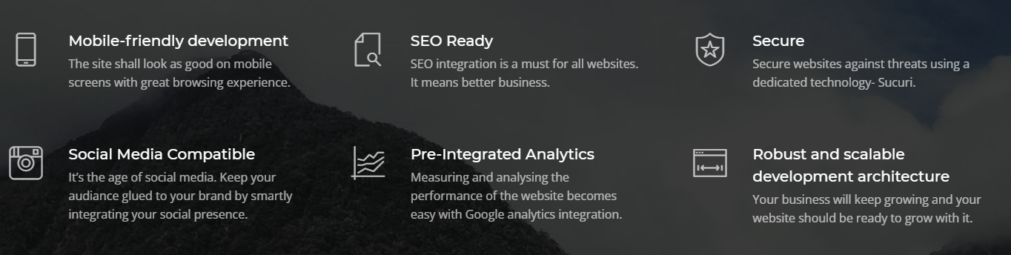

**Revolutionising Cloud Working Space & Freelancing**